**New Business Proposal C:**

Area Directors in District 21 are to be elected by their respective Area Councils prior to the next District program year.

**Division and Area Council Meetings**

[**District Management for Division and Area Councils**](https://www.toastmasters.org/Membership/Leadership/district-leader-tools/district-management/division-and-area-council-meeting/)

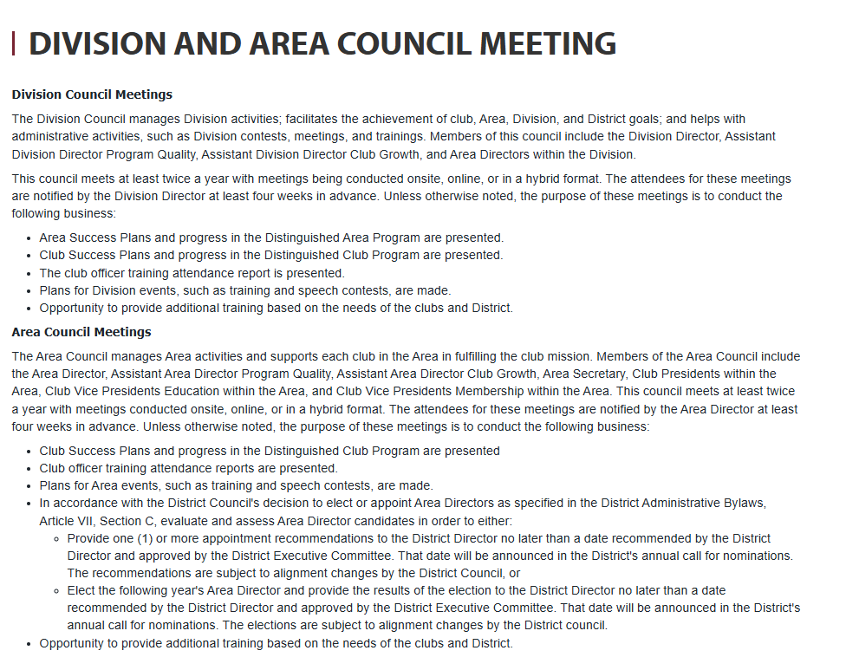

**Election of Area Directors**

[District Administrative Bylaws Section VII Article C](https://www.toastmasters.org/membership/leadership/governing-documents#ArticleVIIOfficers327)

1. **Other Officers**
   1. The other officers of this District shall be the District Public Relations Manager, the District Administration Manager, the District Finance Manager, and the Area Director for each Area.
2. These officers may be elected or appointed.
3. The decision to elect or appoint is made by the District Council and remains in effect until changed by the council.
4. The decision to elect or appoint fully or partially remote District leaders by role is made by the District Council and remains in effect until changed by the council.
5. Any changes to these decisions must be made prior to November 1 of the District program year in which the elections or appointments will occur.
   1. Officers appointed by the District Director are subject to the approval of the District Executive Committee and the District Council by September 30.
   2. The District Public Relations Manager, the District Administration Manager, and the District Finance Manager shall be eligible for re-election or re-appointment for one (1) succeeding term, regardless of District.
   3. Area Directors are elected by the Area Councils or appointed by the District Director considering the recommendation of the Area Councils.
   4. Area Directors shall be eligible for re-election or re-appointment for one (1) succeeding term, regardless of District.